Sint Maarten Yacht Club

JOB DESCRIPTION SMYC MERCHANDISER & OFFICE ASSISTANT

Position description:
The SMYC is looking for a part-timer to join the team as merchandiser & office assistant. Main responsibilities consist of communications, merchandise coordination, sales and marketing & promotions. This person would be the point person to provide information regarding the island, maritime industry and the yacht club.

Communications & promotions:
- Produce monthly newsletter
- Confirm registrations for events
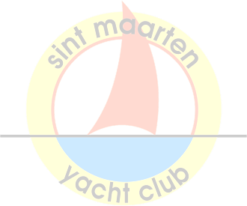
- Coordination between committees
- Produce and send out flyers
- Maintain social media channels
- Press Releases
- Website maintenance
- Membership coordination and communications

Merchandise:
- In charge of merchandise sales
- Maintain stock, place orders and coordinate merchandise location
- Control merchandise opportunities online and on island

Other duties:
- Basic administrative duties and errands Requirements:
- Excellent communication skills
- Ample experience working and living on Sint Maarten
- Experience in retail & sales
- Ability to work in a dynamic environment
- Pro-active attitude
- Independent worker, as well as supportive of a team
- Proficiency in standard Office software (Outlook, Excel, Word, Powerpoint)
- Experience with social media management
- Proficiency in English
- Driver’s license

Hours:

Requires working on weekends.

1 year contract; Part time (2 days a week) from June till September 2023, potentially going to 3 days a week from September onwards.

Sint Maarten, Dutch or American nationality required or in possession of valid work or residence permit. Submit CV and Motivation letter to saskia@smyc.com
Applications close May 27th – Starting date asap.

90 Welfare Road, Simpson Bay Bridge, ST. MAARTEN
Tel: +1(721) 544 2079 Mob: +1(721) 5810559 Email: manager@smyc.com, www.smyc.com

